King Fahd University of Petroleum & Minerals
College of Computer Sciences & Engineering
Information & Computer Science Department
ICS 202: Data Structures

Major Examination 2

First Semester (061)

Duration: 120 minutes

MAKE SURE YOUR EXAM BOOKLET CONTAINS 4 QUESTIONS IN 15 PAGES. THE LAST TWO PAGES CONTAIN THE HELP SHEET; YOU MAY DETACH THESE LAST TWO PAGES.

Notes:
- Attempt ALL questions.
- Show all details of your answers.
- If you need to make any reasonable assumptions, write them down as part of your answers.
Scores:
Questions | Points | Scores
Q1 | 30
Q2 | 20
Q3 | 25
Q4 | 25
Total Score | 100

Q1. [(30 Points)] Answer each of the following questions completely but briefly. Each question is worth 2 points.

- Write the recurrence relation that represents the running time T(n) of the following method:

public static int myMethod(int n){
if(n == 1)
return 3;
else
return 5 * myMethod(n/3) - 3*myMethod(n/3);
}

Note: DO NOT EXPAND THE RECURRENCE RELATION

- The frequency of characters in a file are given in the following table:

character | E | N | P
frequency | 19 | 3 | 20

Draw the Huffman code tree [Use the procedure of ICS202]

- Write the depthfirst postorder traversal of the following Binary tree:

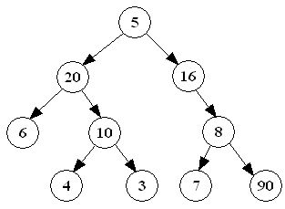

- Write the adjacency-matrix representation of the following graph:

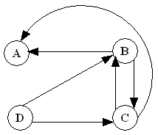

 | A | B | C | D
A
B
C
D

- Why are B-trees more efficient than AVL trees in secondary memory storage?

- The following code-word set is a valid set of Huffman code-words. True or false?
{110, 00, 100, 101, 1101 , 1110}

- Draw a graph containing three vertices that is weakly connected

- What is the In-Degree and Out-Degree of vertex 2 in the following graph
4
5
3
2
1

In-degree | Out-degree

- What is the height of a complete binary tree containing 26 nodes?

- Which traversal method visits the keys of a Binary Search tree in increasing order?

- The following array represents a MinHeap in which indexes start at 1.

10 | 20 | 30 | 25 | 27 | 34 | 38 | 28

- What is the key of the parent of the node whose key is 27? ______

- What is the key of the left child of the node whose key is 25? ______

- Suppose a new node having key 23 is added to the heap in the above question. Show the resulting heap as an array.

- Suppose a new node having key 9 is inserted in the following AVL tree. Draw the resulting AVL tree.

- For the root of a B-Tree of order 7:
  - What is the minimum number of keys? _______
  - What is the maximum number of keys? _______

- After a new node has just been added to an AVL tree, what is the condition for a double right-left rotation?

Q2. (a) [10 points] The running time T(n) of an algorithn is represented by the following recurrence relation:
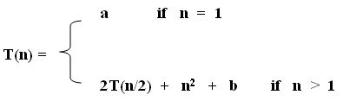
Where a and b are constants. Solve the recurrence relation by iteration and then determine the big-O complexity of the algorithm.

You may find the following summation formulae useful:
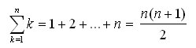 | 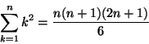
$\sum_{k=0}^{n−1}{2^{k}}=2^{n}−1$ | $\sum_{k=0}^{n−1}{\frac{1}{2^{k}}}=2−\frac{1}{2^{n−1}}$

Q2.(b)[10 points] The BinaryHeap class implements a min-heap by using a MyComparable array with indexes that start at 1. Write an iterative instance method:
public int countParentNodes( )
of the BinaryHeap class that will count, in the invoking object, parent nodes each of which has a left- and right-child that does not satisfy the min-heap ordering property.

Note: Your method must throw an appropriate exception if the min-heap is empty.

Q3.(a) [10 points] In BinarySearchTree class, write a recursive instance method:

public int countDescendants(MyComparable target)

that counts and returns the number of all descendants of the node with key target. The method must throw an appropriate exception if the calling binary search tree is empty.

Note: Do not use instance variables, static variables, looping constructs, getEnumeration(), or any of the existing BinaryTree, BinarySearchTree, or AbstractTree methods [Except: isEmpty( ), getLeftBST( ) or getRightBST( )]

Hint: Your recursive method countDescendants may call another private recursive instance method at an appropriate stage.

Q3.(b) [8 points] Suppose that the method, myMethod(), shown below is an instance
method of the BinaryTree class:

public void myMethod(){
QueueAsLinkedList queue = new QueueAsLinkedList();
if (!isEmpty())
queue.enqueue(this);
while(! queue.isEmpty()) {
BinaryTree tree = (BinaryTree) queue.dequeue();
System.out.print(tree.key + " ");
if(! tree.getRight().isEmpty())
queue.enqueue(tree.getRight());
if(! tree.getLeft().isEmpty())
queue.enqueue(tree.getLeft());
}
}

Show the output if the above myMethod is called on the BinaryTree shown below:

Output:

Q3.(c) [ 7points] Draw the mixed Adjacency-list representation of the following graph:

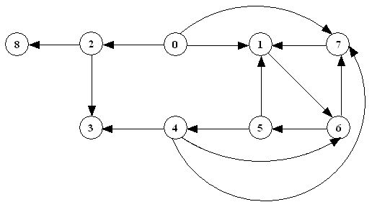

Q4. (a) [15 points] Attempt each of the following questions:
- [5 points] Draw the resulting binary heap tree when the following array is converted bottom-up into a min-heap:

25 | 18 | 50 | 20 | 10 | 30 | 40 | 6 | 4 | 2 | 5

- [6 points] Draw the intermediate and final B-tree when the keys 75, 100, 60 are inserted, in this order, in the B-Tree of order 3 given below. Your output should have at least 3 trees, one after each insertion operation. [Note: The second and third insertions are to be done on the B-tree modified by the previous insertion]
20
35
55
81

85
70
105

- [4 points] Draw the intermediate and the final B-tree when the keys 50, and then 10 are deleted from the B-Tree of order 3 given below. Your output should have at least 2 trees, one after each deletion operation. [Note: The second deletion is to be done on the B-tree modified by the previous deletion]

10
80
50
93
20
60

Q4. (b) [10 points] A vertex is said to be a bridge if it has at least two emanating edges and only one incident edge. Write an instance method,

public MyLinkedList getAllBridges()

of the GraphAsLists class, that returns the set of all bridge vertices of a graph.

ICS 202 – Data Structures
Quick Reference Sheet

public interface MyComparable {  boolean isLT (MyComparable object);  boolean isLE (MyComparable object);  boolean isGT (MyComparable object);  boolean isGE (MyComparable object);  boolean isEQ (MyComparable object);  boolean isNE (MyComparable object);  int compare (MyComparable object);  }  public interface Enumeration {  boolean hasMoreElements( );  Object nextElement( ) throws NoSuchElementException;  }  public interface Visitor {  void visit (Object object);  boolean isDone( );  }  public interface Container extends MyComparable {  int getCount( );  boolean isEmpty( );  boolean isFull( );  void purge( );  void accept(Visitor visitor);  Enumeration getEnumeration( );  }  public interface SearchableContainer extends Container {  boolean isMember (MyComparable object);  void insert (MyComparable object);  void withdraw (MyComparable obj);  MyComparable find (MyComparable object);  }  public class Association extends AbstractObject  public Association(MyComparable c, Object o)  public Association(MyComparable c)  public MyComparable getKey( )  public Object getValue( )  public void setValue( )  public String toString( )  } | public class MyLinkedList {  public void purge( )  public Element getHead( )  public Element getTail( )  public Element find(Object obj)  public boolean isEmpty( )  public Object getFirst( )  public Object getLast( )  public void prepend(Object obj)  public void append(Object obj)  public void assign(MyLinkedList list)  public void extract(Object obj)  public String toString( )  public final class Element {  public Object getDatum( )  public Element getNext( )  public void insertAfter(Object o)  public void insertBefore(Object o)  public void extract( )  }  }  public interface Stack extends Container {  Object getTop( );  void push(Object obj);  Object pop( );  }  public interface Queue extends Container {  Object getHead( );  void enqueue(Object obj);  Object dequeue( );  }  public interface PriorityQueue extends Container {  void enqueue(MyComparable c);  MyComparable findMin( );  MyComparable dequeueMin( );  }

public interface Tree extends Container {  Object getKey( );  Tree getSubtree(int i);  boolean isLeaf( );  int getDegree( );  int getHeight( );  void preorderTraversal(Visitor visitor);  void inorderTraversal(Visitor visitor);  void postorderTraversal(Visitor visitor);  void breadthFirstTraversal(Visitor visitor);  }  public class BinaryTree extends AbstractTree  public BinaryTree(Object obj, BinaryTree left, BinaryTree right)  public BinaryTree( )  public BinaryTree(Object obj)  public void purge( )  public boolean isLeaf( )  public int getDegree( )  public boolean isEmpty( )  public Object getKey( )  public BinaryTree getLeft( )  public BinaryTree getRight( )  public void attachKey(Object obj)  public Object detachKey( )  }  public interface SearchTree extends Tree, SearchableContainer {  MyComparable findMin( );  MyComparable findMax( );  }  public class BinarySearchTree extends BinaryTree implements SearchTree {  private BinarySearchTree getLeftBST( )  private BinarySearchTree getRightBST( )  public boolean isMember(MyComparable c)  public MyComparable find(MyComparable c)  public MyComparable findMin( )  public MyComparable findMax( )  public void attachKey(Object obj)  public void insert(MyComparable comparable)  public void withdraw(MyComparable comparable)  }  public class AVLTree extends BinarySearchTree {  public AVLTree( )  public int getHeight( )  public void insert(MyComparable comparable)  public void attachKey(Object obj)  public Object detachKey( )  } | public interface Graph extends Container {  int getNumberOfEdges( );  int getNumberOfVertices( );  boolean isDirected( );  void addVertex(int v);  void addVertex(int v, Object obj);  Vertex getVertex(int v);  void addEdge(int v, int w);  void addEdge(int v, int w, Object obj);  Edge getEdge(int v, int w);  boolean isEdge(int v, int w);  boolean isConnected( );  boolean isCyclic( );  Enumeration getVertices( );  Enumeration getEdges( );  void preorderDepthFirstTraversal(Visitor v, int  start);  void postorderDepthFirstTraversal(Visitor v,  int start);  void breadthFirstTraversal(Visitor visitor, int  start);  }  public interface Digraph extends Graph {  boolean isStronglyConnected( );  void topologicalOrderTraversal (Visitor visitor);  }  public interface Edge extends MyComparable {  Vertex getV0( );  Vertex getV1( );  Object getWeight( );  boolean isDirected( );  Vertex getMate(Vertex vertex);  }  public interface Vertex extends MyComparable {  int getNumber( );  Object getWeight( );  Enumeration getIncidentEdges( );  Enumeration getEmanatingEdges( );  Enumeration getPredecessors( );  Enumeration getSuccessors( );  }

